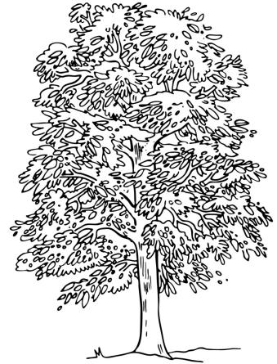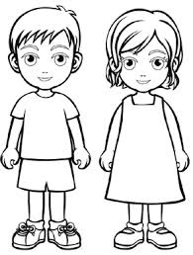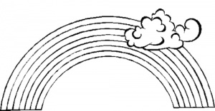  ............................................................................................................................  Д ДА ОДЕ  ...................................................................................................................  дан деда Дана  ________________________________________________________________  ________________________________________________________________  ________________________________________________________________  ________________________________________________________________ |  |  | ............................................................................................................................  Д ДА ОДЕ  ...................................................................................................................  дан деда Дана  ________________________________________________________________  ________________________________________________________________  ________________________________________________________________  ________________________________________________________________

